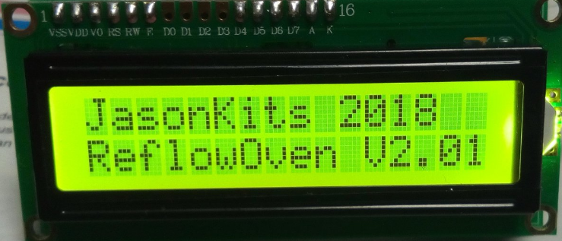*Jason Kits Reflow Oven*

- User Manual and Installation

This board features:

ATMEGA328P processor clocked at 16 MHz

HD44780 16x2 LCD display

MAX31855 thermo-couple Sensor on board

Can be interfaced with a 2 button analogue keypad *(Default)

Can be interfaced with a 4 button digital keypad

Has provision for heartbeat led *(Default)

Transistor Buffered Buzzer output *(Default)

Power input protected with inline PTC Fuse and Crowbar diode.

Transistor Buffered SSR Output to drive Solid state Relay Module: 5V Drive

Serial Output with formatted csv data for monitoring on PC.

Keypad - Control

Switch 1: Starts Oven Reflow Process - pressing it second time Stops Reflow Process.

Switch 2: Selects Profile, Lead Free Paste, Leaded Paste

Led: Shows State of controller – Heartbeat – Flashes when timer is on.

Buzzer: Beeps when booted, when timer starts, when an error detected, when Reflow is ready.

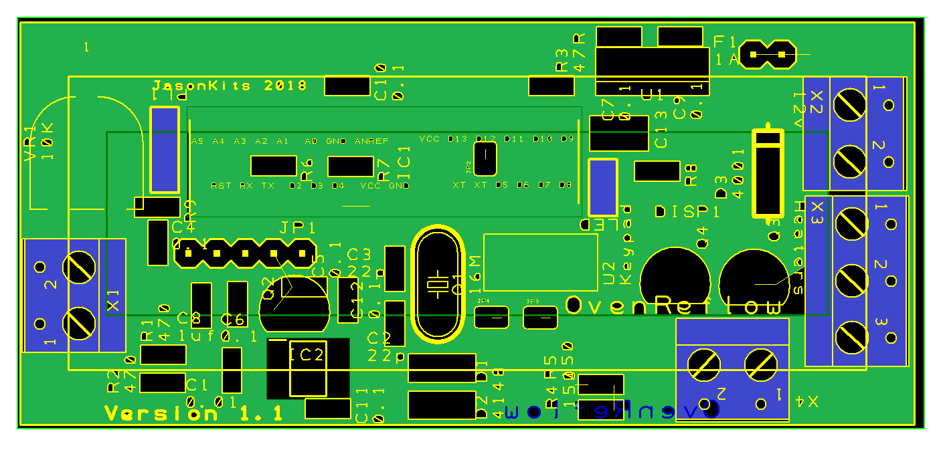

Connectors

|  |  |
| --- | --- |
| X1: THERMOCOUPLE K-Type | X2: POWER IN + 12V |
| X3: SSR OUTPUT 5 Volt | X4: BUZZER 5 Volt |
| JP1: Serial Logging Port/ Firmware Update Port. | LED: LED HEARTBEAT |

Reflow States

|  |
| --- |
| **Ready** : Controller is in idle state and Ready to take Command |
| **Pre-Heat**: The first step is to increase the temperature from room temperature to 150 °C. The ramp up rate is 1 to 3°C per second. |
| **Soaking**: The second step used to activate the solder paste and allow the flux to clean the pads being soldered. |
| **Reflow** : The third step is used to allow solder paste to reach it's melting point Known as the 'liquidous temperature' which is about 218 °C for lead free solder paste (Sn-Ag-Cu based).Here the solder joins the component to the board. |
| **Cooling** : The third step is used to allow solder paste to reach it's melting point Known as the 'liquidous temperature' which is about 218 °C for lead free solder paste (Sn-Ag-Cu based).Here the solder joins the component to the board. |
| **Done** : The controller completed the reflow process |
| Error States: These error states are displayed on the lcd. |
| **Hot!** : Probe is too hot |
| **Error!** : An error was encountered. |

Profiles Temperatures

|  |  |
| --- | --- |
| Lead Free Profile SnAgCu(Sn96.5Ag3.0Cu0.5) | Leaded Profile SnPb (Sn63Pb37) |
| Soak Max : 200 Degrees | Soak Max : 180 Degrees |
| Reflow Max: 250 Degrees | Reflow Max: 224 Degrees |

**Display**

The LCD 16 characters by 2 lines display all the required information. These are as follows:

Line 1 : Displays the Re-flow state together with the Temperature it needs to Reach.

Line 2 : Displays the actual temperature being read from the sensor , the time count in seconds and the Soldering Profile selected.

Ready 000.00C

18.98 C 000.0s SnAg

**Power Supply Considerations**

The board accepts 9v to 24v input and protected with an inline PolyFuse and a reverse polarity protection.

**Serial Port**

The Board features a serial port TTL output (57600). A USB to serial converter is required to monitor and log the data. The controller board can be updated with new firmware by using the serial port.

**Keypads**

The board comes configured with two buttons.

Schematic

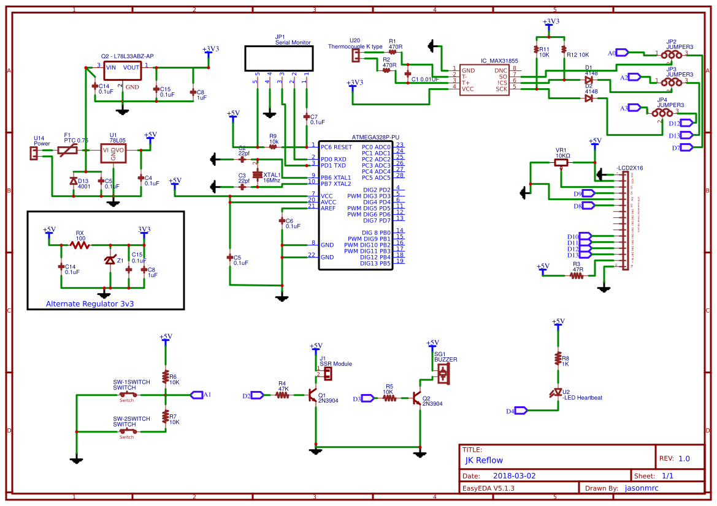

Bare Kit Installation Instructions.

Step 1: Start by installing all SMD0805 resistors followed by SMD 0805 capacitors. Next, install the MAX31855 SOP-8 IC and continue installing the various parts following the height as the guide. Smallest first going to the highest.

Step 2. Install all sockets. Make sure to install the IC socket pin 1 facing to the left.

Step 3. Install all connectors. These are installed on the rear of the board.

Step 4. Install the lcd connector, clip the 3d printed part spacer on the LCD. Moreover, solder the lcd connectors from both sides.

Step 5. Check that all components have been installed and apply 12v to the power input. Adjust the contrast preset VR1, until the characters are shown on the display.

Step 6. Test the switches functionality and then connect the sensor. It should start reading the ambient temperature.

Component List

|  |  |  |  |  |  |
| --- | --- | --- | --- | --- | --- |
|  |  |  |  |  |  |
| Ref Name | Qty | Component | Value | Package | Comment |
| D3 | 1 | 1N4001 | 4001 | DIOD05 |  |
| Q3 | 1 | 2N3904 | 2N3904 | TO-92 |  |
| Q4 | 1 | 2N3904 | 2N3904 | TO-92 |  |
| PL2 | 1 | 2WP - XH -JST | LED RED | DSC |  |
| PL1 | 1 | 3WP | 3 pin 2.54 mm | SIL |  |
| U2 | 1 | 4SIL | 4 pin 2.54mm | SIL |  |
| R6 | 1 | 805 | 10K | SM |  |
| R7 | 1 | 805 | 10K | SM |  |
| R8 | 1 | 805 | 1K | SM |  |
| R9 | 1 | 805 | 10K | SM |  |
| R12 | 1 | 805 | 10K | SM |  |
| R11 | 1 | 805 | 10K | SM |  |
| R3 | 1 | 805 | 47R | SM |  |
| R4 | 1 | 805 | 47K | SM |  |
| R5 | 1 | 805 | 10K | SM |  |
| R1 | 1 | 805 | 470 | SM |  |
| D13 | 1 | 805 | 470 | SM |  |
| U1 | 1 | 78L05 | 78L05 | TO-92 |  |
| IC1 | 1 | ATMEGA328P-PU | ATMEGA328 | DIP-28 |  |
| C4 | 1 | C0805 | 0.1 | SM |  |
| C5 | 1 | C0805 | 0.1 | SM |  |
| C6 | 1 | C0805 | 0.1 | SM |  |
| C7 | 1 | C0805 | 0.1 | SM |  |
| C9 | 1 | C0805 | 0.1 | SM |  |
| C10 | 1 | C0805 | 0.1 | SM |  |
| C1 | 1 | C0805 | 0.01 | SM |  |
| C14 | 1 | C0805 | 0.1 | SM |  |
| C15 | 1 | C0805 | 0.1 | SM |  |
| C8 | 1 | C0805 | 1uf | SM |  |
| C2 | 1 | C0805 | 22p | SM |  |
| C3 | 1 | C0805 | 22p | SM |  |
| C13 | 1 | CP-SM | 100uF | ELEC CAP |  |
| Q1 | 1 | CRYSTALHC49UV | 16Mhz | HC49U-V |  |
| F1 | 1 | Poly-Fuse | 1A | 1X02 |  |
| JP2 | 1 | JUMPER-32-3 | pcb 3 pin | SJ_3_PASTE2&3 |  |
| JP3 | 1 | JUMPER-32-3 | pcb 3 pin | SJ_3_PASTE2&3 |  |
| JP4 | 1 | JUMPER-32-3 | pcb 3 pin | SJ_3_PASTE2&3 |  |
| DISP1 | 1 | LCD-16X2 | lcd1602 | LCD-16X2 |  |
| JP1 | 1 | M05PTH | 5 pin 2.54mm | 1X05 |  |
| IC2 | 1 | MAX31855RASA+ | max31855kasa+ | SOP-8 |  |
| Q2 | 1 | 78L33 | 78l33 * | TO-92 |  |
| VR1 | 1 | PRESET | 10K | PRESET VR |  |
| D1 | 1 | SOD80D | 4148 | DIODE 2 PIN |  |
| D2 | 1 | SOD80D | 4148 | DIODE 2 PIN |  |
| X1 | 1 | W237-02P | 2 pin terminal | 2 PIN TERMINAL |  |
| X2 | 1 | W237-02P | 2 pin terminal | 2 PIN TERMINAL |  |
| X4 | 1 | W237-02P | 2 pin terminal | 2 PIN TERMINAL |  |
| X3 | 1 | W237-03P | 3 pin terminal | 2 PIN TERMINAL |  |
| Z1 | 1 |  | Zener 3v3 | ZENER 3V3 | OPTIONAL |
| RX | 1 |  | 47R - 100R | ¼ Watt Resistor | OPTIONAL |
| SW1 | 1 | Push Switch |  |  |  |
| SW2 | 1 | Push Switch |  |  |  |

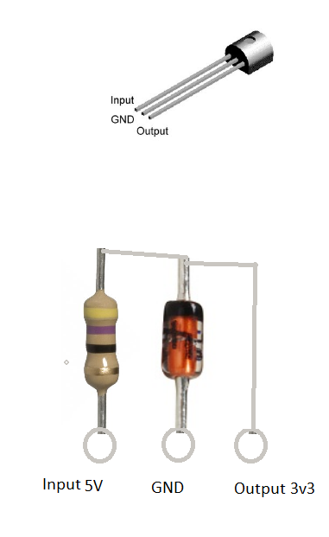

Note for Version 1.1

Instead of using the regulator 78l33 the combination of resistor RX and Z1 is used. Please follow the steps to install these components.

Locate resistor RX and install it on the input pin left most.

Locate the zener diode and install it on the centre pin.

Bend the other leg of the resistor to the third hole of the regulator (output). Make sure you solder the zener other side with the resistor as shown in the picture.

Three Pin Analog Keyboard Wiring

Crimp 3 wires to the connector supplied and solder it to the two push button switches as indicated in the diagram.

